**Assignment No:-68**

Name:-Suryawanshi Sangramsingh Sambhaji

Batch: - Delta - DCA (Java) 2024 Date:-30/8/2024

**1.Write a program to reverse an ArrayList.**

package AssignmentNo69;

import java.util.ArrayList;

import java.util.Arrays;

public class RevList {

public static void main(String[] args) {

ArrayList<Integer> al = new ArrayList<Integer>(Arrays.*asList*(20,34,12,65,80));

System.***out***.println("\nGiven arraylist :\n"+al);

int left = 0;

int right = al.size()-1;

while(right > left)

{

int temp = al.get(left);

al.set(left, al.get(right));

al.set(right, temp);

left ++;

right --;

}

System.***out***.println("\nReversse :\n"+al);

}

}

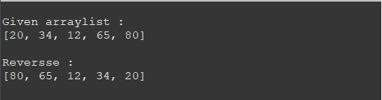

**2.Find the Intersection of Two ArrayLists:**

package AssignmentNo69;

import java.util.ArrayList;

import java.util.Arrays;

public class Intersection {

public static void intersection(ArrayList<Integer> a1, ArrayList<Integer> a2)

{

a1.retainAll(a2);

System.***out***.println("\nIntersection : ");

System.***out***.println(a1);

}

public static void main(String[] args) {

ArrayList<Integer> a1 = new ArrayList<Integer>(Arrays.*asList*(2,5,7,8,9));

ArrayList<Integer> a2 = new ArrayList<Integer>(Arrays.*asList*(10,5,7,90,9));

System.***out***.println("List 1 -> "+a1);

System.***out***.println("List 2 -> "+a2);

*intersection*(a1, a2);

}

}

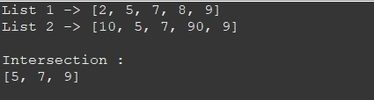

**3.Write a function to find the common elements between two ArrayLists.**

package AssignmentNo69;

import java.util.ArrayList;

import java.util.Arrays;

public class Intersection {

public static void intersection(ArrayList<Integer> a1, ArrayList<Integer> a2)

{

a1.retainAll(a2);

System.***out***.println("\nIntersection : ");

System.***out***.println(a1);

}

public static void main(String[] args) {

ArrayList<Integer> a1 = new ArrayList<Integer>(Arrays.*asList*(2,5,7,8,9));

ArrayList<Integer> a2 = new ArrayList<Integer>(Arrays.*asList*(10,5,7,90,9));

System.***out***.println("List 1 -> "+a1);

System.***out***.println("List 2 -> "+a2);

*intersection*(a1, a2);

}

}

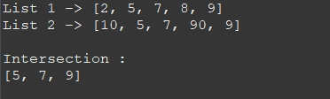

**4.Write a program to check if an ArrayList is empty.**

package AssignmentNo69;

import java.util.ArrayList;

public class Empty {

public static void main(String[] args) {

ArrayList<Integer> a1 = new ArrayList<Integer>();

System.***out***.println("ArrayList -> "+a1);

System.***out***.println("\nIs ArrayList empty ?");

System.***out***.println(a1.isEmpty()?"Yes" : "No");

}

}

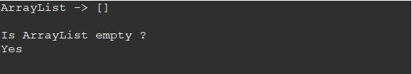

**5.Write a function to find the maximum element in an ArrayList.**

package AssignmentNo69;

import java.util.ArrayList;

import java.util.Arrays;

public class Max {

public static Integer getMax(ArrayList<Integer> al)

{

int max =0;

for(int i=0;i<al.size();i++)

{

if(al.get(i) > max)

{

max = al.get(i);

}

}

return max;

}

public static void main(String[] args) {

ArrayList<Integer> al = new ArrayList<Integer>(Arrays.*asList*(2,5,7,8,9));

System.***out***.println("ArrayList -> "+al);

System.***out***.println("\nMax : "+*getMax*(al));

}

}

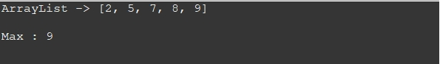

**6.Sort an ArrayList of Strings in ascending order.**

package AssignmentNo69;

import java.util.ArrayList;

import java.util.Arrays;

public class AscendingSort {

public static void main(String[] args) {

ArrayList<Integer> al = new ArrayList<Integer>(Arrays.*asList*(7,3,1,45,9));

System.***out***.println("ArrayList -> "+al);

al.sort(null);

System.***out***.println("Sorted -> "+al);

}

}

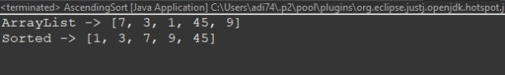

**7.Write a program to remove an element from an ArrayList by its index.**

package AssignmentNo69;

import java.util.ArrayList;

import java.util.Arrays;

import java.util.Scanner;

public class RemoveEle {

public static void main(String[] args) {

ArrayList<Integer> al = new ArrayList<Integer>(Arrays.*asList*(7,3,1,45,9));

System.***out***.println("ArrayList -> "+al);

Scanner sc = new Scanner(System.***in***);

System.***out***.println("Enter index to remove : ");

int ind = sc.nextInt();

al.remove(ind);

System.***out***.println("After removing -> "+al);

}

}

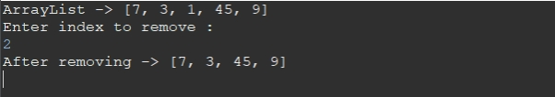

**8.Write a function to find the union of two ArrayLists.**

package AssignmentNo69;

import java.util.ArrayList;

import java.util.Arrays;

public class Union {

public static void main(String[] args) {

ArrayList<Integer> a1 = new ArrayList<Integer>(Arrays.*asList*(2,5,7,8,9));

ArrayList<Integer> a2 = new ArrayList<Integer>(Arrays.*asList*(10,5,7,90,9));

System.***out***.println("List 1 -> "+a1);

System.***out***.println("List 2 -> "+a2);

ArrayList<Integer> union = new ArrayList<Integer>(a1);

for(int i=0;i<a2.size();i++)

{

if(!union.contains(a2.get(i)))

{

union.add(a2.get(i));

}

}

System.***out***.println("\nUnion -> "+union);

}

}

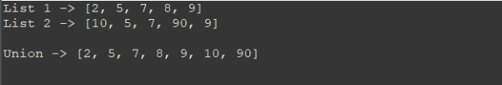

**9.Write a program to check if an ArrayList contains a specific element.**

package AssignmentNo69;

import java.util.ArrayList;

import java.util.Arrays;

import java.util.Scanner;

public class Search {

public static void main(String[] args) {

ArrayList<Integer> al = new ArrayList<Integer>(Arrays.*asList*(7,3,1,45,9));

System.***out***.println("ArrayList -> "+al);

Scanner sc = new Scanner(System.***in***);

System.***out***.println("Enter element to check : ");

int ele = sc.nextInt();

System.***out***.println(al.contains(ele) ? "\nElement is present" : "\nElement is absent");

}

}

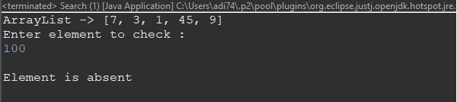

**10.Shuffle the elements of an ArrayList.**

package AssignmentNo69;

import java.util.ArrayList;

import java.util.Arrays;

import java.util.Collections;

public class Shufle {

public static void main(String[] args) {

ArrayList<Integer> al = new ArrayList<Integer>(Arrays.*asList*(7,3,1,45,9));

System.***out***.println("ArrayList -> "+al);

Collections.*shuffle*(al);

System.***out***.println("\nAfter shuffling -> "+al);

}

}

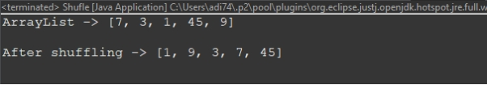

**11.Convert an ArrayList to an array.**

package AssignmentNo69;

import java.util.ArrayList;

import java.util.Arrays;

public class toArray {

public static void main(String[] args) {

ArrayList<Integer> al = new ArrayList<Integer>(Arrays.*asList*(7,3,1,45,9));

System.***out***.println("ArrayList -> "+al);

Object[] a = al.toArray();

System.***out***.println("Array -> "+Arrays.*toString*(a));

}

}

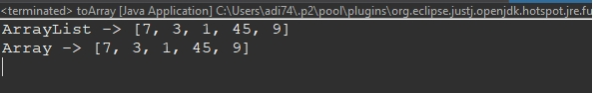

**12.Find Common Elements in Three ArrayLists:**

package AssignmentNo69;

import java.util.ArrayList;

import java.util.Arrays;

public class CommonThree {

public static void main(String[] args) {

ArrayList<Integer> a1 = new ArrayList<Integer>(Arrays.*asList*(2,5,56,7,9));

ArrayList<Integer> a2 = new ArrayList<Integer>(Arrays.*asList*(10,1,7,90,5));

ArrayList<Integer> a3 = new ArrayList<Integer>(Arrays.*asList*(45,5,7,90,99));

System.***out***.println("List 1 -> "+a1);

System.***out***.println("List 2 -> "+a2);

System.***out***.println("List 3 -> "+a3);

System.***out***.println("\nCommon elements : ");

for(int i=0;i<a1.size();i++)

{

if(a2.contains(a1.get(i)) && a3.contains(a1.get(i)))

{

System.***out***.print(a1.get(i)+" ");

}

}

}

}

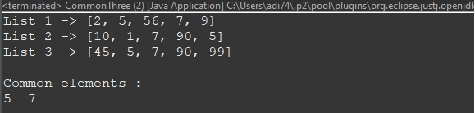

**13.Remove all occurrences of a specific element from an ArrayList.**

package AssignmentNo69;

import java.util.ArrayList;

import java.util.Arrays;

import java.util.Scanner;

public class RemoveOc {

public static void main(String[] args) {

Scanner sc = new Scanner(System.***in***);

ArrayList<Integer> al = new ArrayList<Integer>(Arrays.*asList*(7,3,1,7,9,7));

System.***out***.println("ArrayList -> "+al);

System.***out***.print("Enter element to remove : ");

int ele = sc.nextInt();

for(int i=0;i<al.size();i++)

{

if(al.get(i)==ele)

{

al.remove(i);

}

}

System.***out***.println("\nAfter removing -> "+al);

}

}

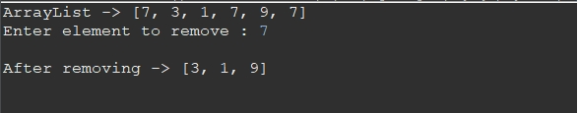

**14.Check if the elements in an ArrayList form a palindrome.**

package AssignmentNo69;

import java.util.ArrayList;

import java.util.Arrays;

public class PalindromeList {

public static boolean isPal(ArrayList<Integer> al)

{

int left =0, right = al.size()-1;

while(right > left)

{

if(al.get(left) != al.get(right))

return false;

left++;

right--;

}

return true;

}

public static void main(String[] args) {

ArrayList<Integer> al = new ArrayList<Integer>(Arrays.*asList*(1,2,3,2,1));

System.***out***.println("ArrayList -> "+al);

if(*isPal*(al))

{

System.***out***.println("\nPalindrome ArrayList.");

}

else

{

System.***out***.println("\nNot Palindrome ArrayList.");

}

}

}

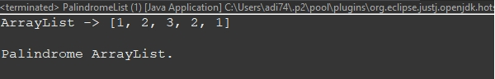

**15.Write a function to find the minimum element in an ArrayList.**

package AssignmentNo69;

import java.util.ArrayList;

import java.util.Arrays;

public class Min {

public static Integer getMin(ArrayList<Integer> al)

{

int min =Integer.***MAX_VALUE***;

for(int i=0;i<al.size();i++)

{

if(al.get(i) < min)

{

min = al.get(i);

}

}

return min;

}

public static void main(String[] args) {

ArrayList<Integer> al = new ArrayList<Integer>(Arrays.*asList*(2,5,1,8,9));

System.***out***.println("ArrayList -> "+al);

System.***out***.println("\nMax : "+*getMin*(al));

}

}

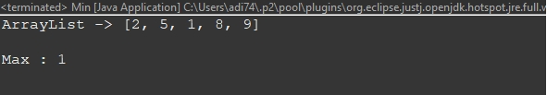

**Lambda Expression Questions:**

**1.Filter Even Numbers:**

**Use a Lambda expression to filter even numbers from a list.**

package ArrayList;

import java.util.ArrayList;

import java.util.Arrays;

interface EvenNo{

ArrayList<Integer> filter(ArrayList<Integer> al);

}

public class EvenLambda {

public static void main(String[] args) {

ArrayList<Integer> al = new ArrayList<Integer>(Arrays.*asList*(13, 69, 19, 1, 2, 3,4,5,6,7,8,10,40));

System.***out***.println("ArrayList : "+al);

EvenNo ob = (list)->{

list.removeIf(n -> n%2!=0);

return list;

};

System.***out***.println("\nFilterd even elements -> "+ob.filter(al));

}

}

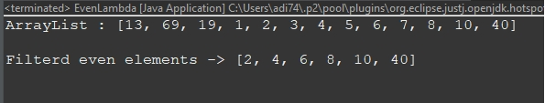

**2.Sort Strings by Length:**

**Sort a list of strings based on their length using a Lambda expression.**

package ArrayList;

import java.util.ArrayList;

import java.util.Arrays;

interface SortString

{

ArrayList<String> sortdata (ArrayList<String> al);

}

public class LengthSort {

public static void main(String[] args) {

ArrayList<String> al = new ArrayList<String>(Arrays.*asList*("Java","c","JavaScript","cpp","Mysql","hibernate"));

System.***out***.println("List : "+al);

SortString ob = (list) ->

{

list.sort((s1,s2)-> Integer.*compare*(s1.length(), s2.length()));

return list;

};

System.***out***.println("\nSorted -> "+ob.sortdata(al));

}

}

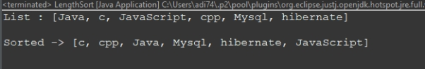

**3.Convert Strings to Uppercase:**

**Convert all strings in a list to uppercase using a Lambda expression.**

package ArrayList;

import java.util.ArrayList;

import java.util.Arrays;

interface Upper

{

ArrayList<String> toUpper (ArrayList<String> al);

}

public class Uppercase {

public static void main(String[] args) {

ArrayList<String> al = new ArrayList<String>(Arrays.*asList*("Java","c","JavaScript","cpp","Mysql","hibernate"));

System.***out***.println("List : "+al);

Upper ob = (list) ->{

list.replaceAll(n-> n.toUpperCase());

return list;

};

System.***out***.println("\nUpper case : "+ob.toUpper(al));

}

}

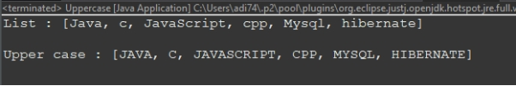

**4.Calculate Average of Numbers:**

**Use a Lambda expression to calculate the average of a list of numbers.**

package ArrayList;

import java.util.ArrayList;

import java.util.Arrays;

interface Average

{

double getAvg(ArrayList<Integer> al);

}

public class AverageLambda {

public static void main(String[] args) {

ArrayList<Integer> al = new ArrayList<Integer>(Arrays.*asList*(13, 6, 19, 1, 2, 3,4,5,6,7,8,10,40));

System.***out***.println("ArrayList : "+al);

Average ob = (list) ->

{

int sum =0;

for(Integer n : list)

sum+=n;

return (double)sum/list.size();

};

System.***out***.println("\nAverage -> "+ob.getAvg(al));

}

}

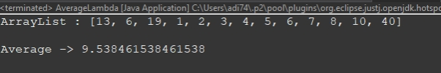

**5.Remove Strings with Length Less Than 5:**

**Remove strings with a length less than 5 from a list using a Lambda expression.**

package ArrayList;

import java.util.ArrayList;

import java.util.Arrays;

interface remove

{

ArrayList<String> removeSmall(ArrayList<String> al);

}

public class RemoveLenght {

public static void main(String[] args) {

ArrayList<String> al = new ArrayList<String>(Arrays.*asList*("Java","c","JavaScript","cpp","Mysql","hibernate"));

System.***out***.println("List : "+al);

remove ob = (list) ->

{

list.removeIf((str) -> str.length()<5);

return list;

};

System.***out***.println("\nRemoved String with length less than 5\n"+ob.removeSmall(al));

}

}

**6.Square of Each Number:**

**Use a Lambda expression to square each number in a list.**

package ArrayList;

import java.util.ArrayList;

import java.util.Arrays;

interface sqaureEle

{

ArrayList<Integer> getSquare(ArrayList<Integer> al);

}

public class Square {

public static void main(String[] args) {

ArrayList<Integer> al = new ArrayList<Integer>(Arrays.*asList*(13, 6, 19, 1, 2, 3,4,5,6,7,8,10,40));

System.***out***.println("ArrayList : "+al);

sqaureEle ob=(list) ->

{

list.replaceAll(n -> n*n);

return list;

};

System.***out***.println("\nSqaure : "+ob.getSquare(al));

}

}

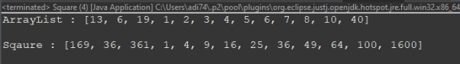

**7.Filter Strings Starting with 'A':**

**Use a Lambda expression to filter strings that start with the letter 'A'.**

package ArrayList;

import java.util.ArrayList;

import java.util.Arrays;

interface startwith

{

ArrayList<String> getA(ArrayList<String> al);

}

public class StartWithA {

public static void main(String[] args) {

ArrayList<String> al = new ArrayList<String>(Arrays.*asList*("Java","account","JavaScript","cpp","action","hibernate","apple"));

System.***out***.println("List : "+al);

startwith ob = (list)->

{

list.removeIf(str -> !str.startsWith("a"));

return list;

};

System.***out***.println("\nFilter string starts with 'a' : "+ob.getA(al));

}

}

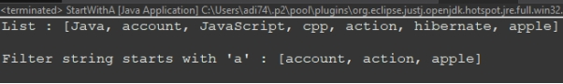

**8.Find Maximum Length String:**

**Find the string with the maximum length using a Lambda expression.**

package ArrayList;

import java.util.ArrayList;

import java.util.Arrays;

interface maxLen

{

String getMax(ArrayList<String> al);

}

public class MaxLength {

public static void main(String[] args) {

ArrayList<String> al = new ArrayList<String>(Arrays.*asList*("Java","account","JavaScript","cpp","action","hibernate","apple"));

System.***out***.println("List : "+al);

maxLen ob = (l)->

{

int max =0;

String len = "";

for(String s : l)

{

if(s.length() > max)

{

max = s.length();

len = s;

}

}

return len;

};

System.***out***.println("\nMax length word : "+ob.getMax(al));

}

}

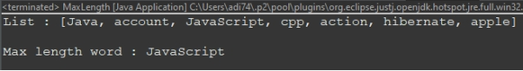

**9.Count Words with Length Greater Than 3:**

**Count the number of words in a list with a length greater than 3 using a Lambda expression.**

package ArrayList;

import java.util.ArrayList;

import java.util.Arrays;

interface count

{

int getCount(ArrayList<String> al);

}

public class CountLength {

public static void main(String[] args) {

ArrayList<String> al = new ArrayList<String>(Arrays.*asList*("Java","c","JavaScript","cp","action","as","I"));

System.***out***.println("List : "+al);

count ob =(l)->

{

l.removeIf(s -> s.length()<3);

return l.size();

};

System.***out***.println("\nAnswer : "+ob.getCount(al));

}

}

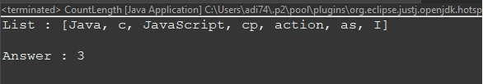

**10.Join Strings with a Separator:**

**Use a Lambda expression to join strings in a list with a specific separator.**

package ArrayList;

import java.util.ArrayList;

import java.util.Arrays;

interface joinStr

{

String getAns(ArrayList<String> al);

}

public class JoinString {

public static void main(String[] args) {

ArrayList<String> al = new ArrayList<String>(Arrays.*asList*("Java","c","JavaScript","cpp","action","job","cat"));

System.***out***.println("List : "+al);

StringBuffer sb = new StringBuffer();

joinStr ob =(list)->{

list.forEach(str ->{

if(sb.length() > 0)

sb.append(", ");

sb.append(str);

});

return sb.toString();

};

System.***out***.println("\nNew String : "+ob.getAns(al));

}

}

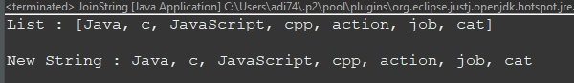

**11.Remove Null Values:**

**Remove null values from a list using a Lambda expression.**

package ArrayList;

import java.util.ArrayList;

import java.util.Arrays;

interface NoNull

{

ArrayList<String> removeNull(ArrayList<String> al);

}

public class RemoveNull {

public static void main(String[] args) {

ArrayList<String> al = new ArrayList<String>(Arrays.*asList*("Java",null,"JavaScript","cp","action",null,null));

System.***out***.println("List : "+al);

NoNull ob = (l)->

{

l.removeIf(n -> n==null);

return l;

};

System.***out***.println("\nRemoved null : "+ob.removeNull(al));

}

}

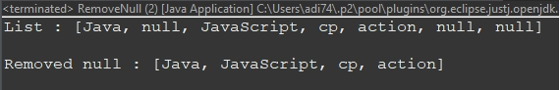

**12.Filter Odd Numbers:**

**Use a Lambda expression to filter odd numbers from a list.**

package ArrayList;

import java.util.ArrayList;

import java.util.Arrays;

interface Odd

{

ArrayList<Integer> getOdd(ArrayList<Integer> al);

}

public class FilterOdd {

public static void main(String[] args) {

ArrayList<Integer> al = new ArrayList<Integer>(Arrays.*asList*(13, 6, 19, 1, 2, 3,4,5,6,7,8,10,40));

System.***out***.println("ArrayList : "+al);

Odd ob =(l)->{

l.removeIf(n -> n%2==0);

return l;

};

System.***out***.println("\nAnswer : "+ob.getOdd(al));

}

}

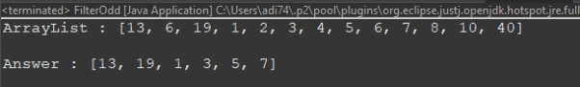

**13.Sort Strings by Last Character:**

**Sort a list of strings based on their last character using a Lambda expression.**

package ArrayList;

import java.util.ArrayList;

import java.util.Arrays;

interface sortchar

{

ArrayList<String> sortChar(ArrayList<String> al);

}

public class SortLast {

public static void main(String[] args) {

ArrayList<String> al = new ArrayList<String>(Arrays.*asList*("Java","c","JavaScript","cp","action","as","i"));

System.***out***.println("List : "+al);

sortchar ob =(l)->{

l.sort((s1, s2) -> Character.*compare*(s1.charAt(s1.length() - 1), s2.charAt(s2.length() - 1)));

return l;

};

System.***out***.println("\nSorted : "+ob.sortChar(al));

}

}

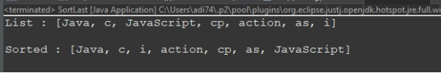

**14.Convert Integers to Doubles:**

**Convert each integer in a list to its corresponding double value using a Lambda expression.**

package ArrayList;

import java.util.ArrayList;

import java.util.Arrays;

interface convert

{

ArrayList<Double> getDouble(ArrayList<Integer> al);

}

public class intToDouble {

public static void main(String[] args) {

ArrayList<Integer> al = new ArrayList<Integer>(Arrays.*asList*(13, 6, 19, 3,4,5));

System.***out***.println("ArrayList : "+al);

convert ob=(l)->{

ArrayList<Double> d = new ArrayList<Double>();

l.forEach(n-> d.add(n.doubleValue()));

return d;

};

System.***out***.println("\nDouble values : "+ob.getDouble(al));

}

}

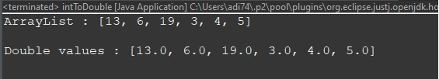

**15.Find Strings with Length Equal to 3:**

**Find strings in a list with a length equal to 3 using a Lambda expression.**

package ArrayList;

import java.util.ArrayList;

import java.util.Arrays;

interface lengthGet

{

ArrayList<String> getAns(ArrayList<String> al);

}

public class Length3 {

public static void main(String[] args) {